MATLAB Homework 2

Matlab Code:
x=input('Please enter x values : ')
h=input('Please enter h values : ')
m=length(x); % lenght of x values
n=length(h); % lenght of h values
xMatrix=[x,zeros(1,n)]; % padding of zeros
hMatrix=[h,zeros(1,m)]; % padding of zeros
for i=1:n+m-1
Y(i)=0;
for j=1:m
if(i-j+1>0)
Y(i)=Y(i)+xMatrix(j)*hMatrix(i-j+1);
else
end %if end
end %second for end
end %first for end
Y
stem(Y); % plot
ylabel('Y[n]'); % Array of coefficents
xlabel('----->n');
title('Convolution');

Screenshot:
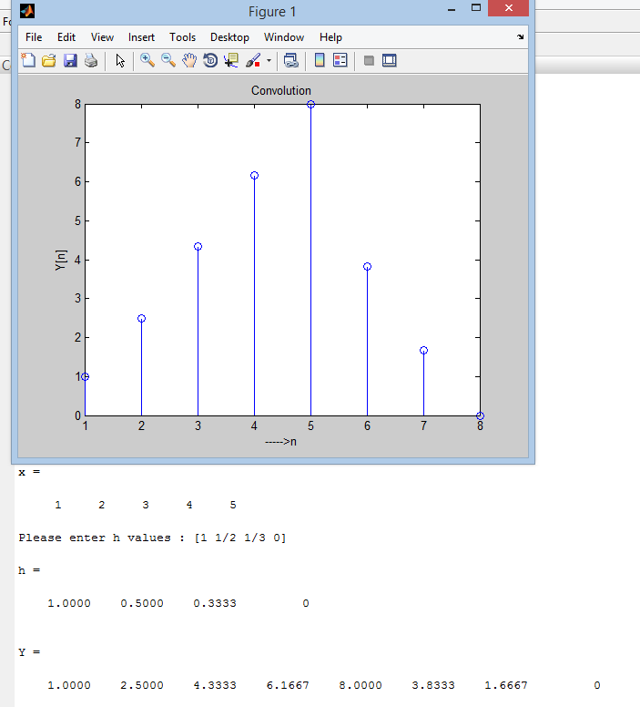
Name and Surname : Sıddık Said AYDOĞAN
Number: 11011052
Date: 01.12.2013

